**Inconsistent red formatting**

Add flags for comments

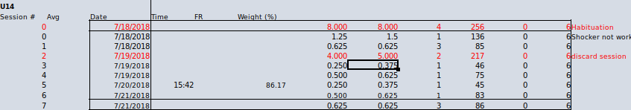

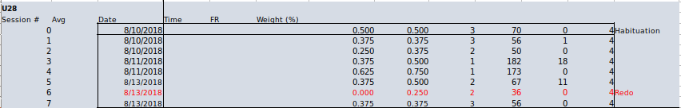

Expected these:

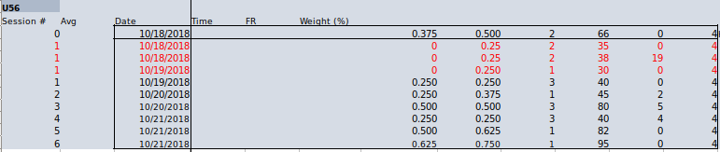

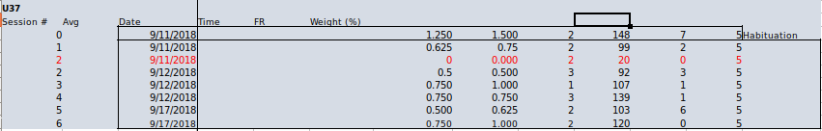

One cell red or not all cells

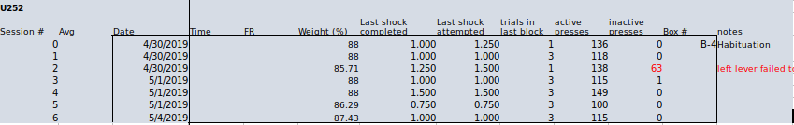

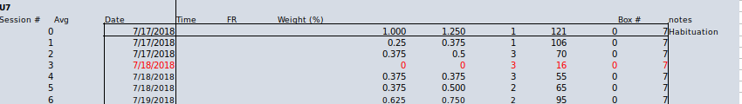

**No red text but red comments**

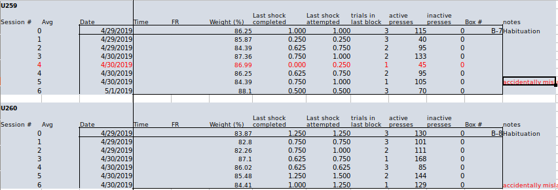

**ID’s for which the values are not the same**